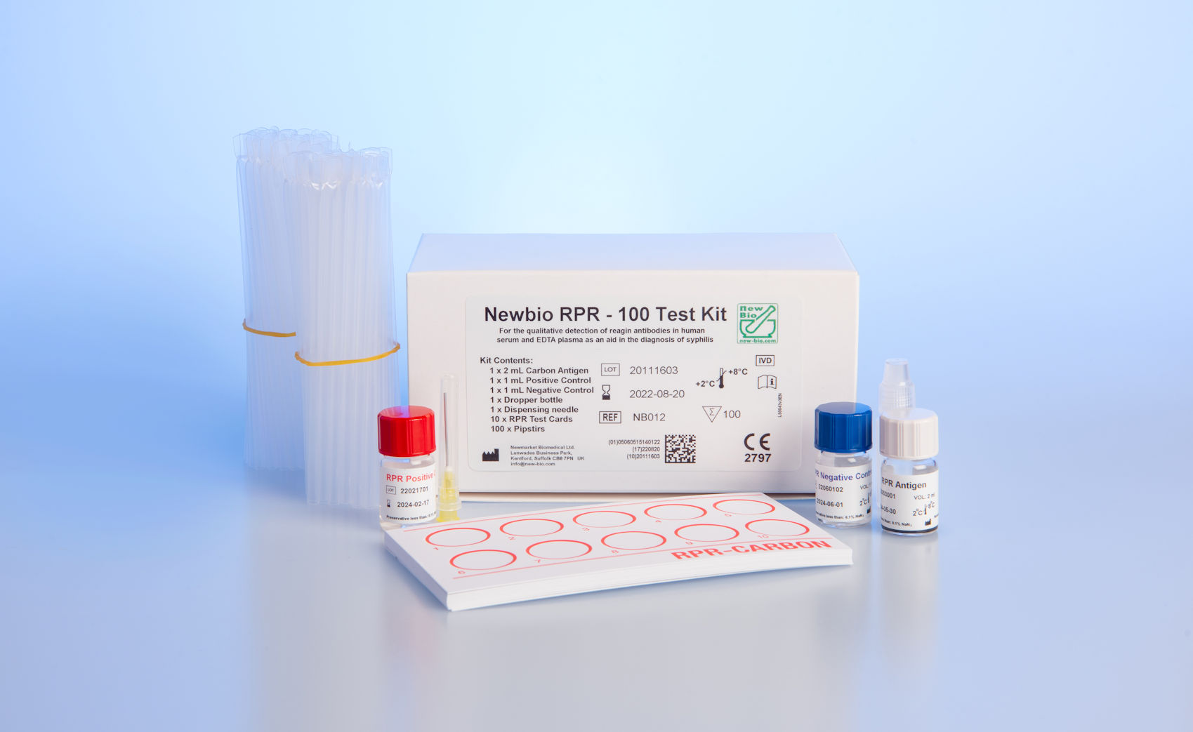

PRINCIPLE OF THE RPR TEST

NewBio RPR (Rapid Plasma Reagin) utilises carbon particles coated with cardiolipin antigen to detect reagin antibodies present in serum or plasma of syphilitic persons.

Specimens that contain reagin cause aggregation of the carbon particles which appear as dark clumps against a white background. The aggregation can be read macroscopically. Non-reactive samples typically appear as a smooth non-aggregated pattern which may form buttons in the centre of the test area.

SPECIFICITY

A study with 1248 syphilis negative EDTA plasma samples showed 99.92% specificity (95% confidence interval 99.55-100.0%)

SENSITIVITY

A study with 158 syphilis positive samples (37 EDTA plasma and 121 sera) showed 98.73% sensitivity (95% confidence interval 95.50-99.85%)

KEY FEATURES

* Quality Assured - 25 years experience
* Ready to use stable liquid reagents
* 24 months shelf life
* Qualitative and titration protocols
* Results ready in 8 minutes
* IVDR Certified
* Manual reading
* Convenient kit sizes

NEWBIO RPR 100 TEST KIT

PRODUCT NO: NB012

QUANTITY: 100 Tests

STABILITY: 24 months @ 2-8°C

NEWBIO RPR 500 TEST KIT

PRODUCT NO: NB013

QUANTITY: 500 Tests

STABILITY: 24 months @ 2-8°C

NEWBIO RPR 100 TESTS

* Non-treponemal carbon antigen test for syphilis
* Carbon particle and VDRL antigen
* All reagents ready to use. Available with controls
* RPR Antigen  
  RPR Negative control  
  RPR Positive Control  
  Test cards  
  Pipstirs  
  Dispensing bottle and needle
* Simple protocol: 1 x 8 minute incubations
* Manual
* Only requires 50 µL sample

NEWBIO RPR 500 TESTS

* Non-treponemal carbon antigen test for syphilis
* Carbon particle and VDRL antigen
* All reagents ready to use. Available with controls
* RPR Antigen  
  RPR Negative control  
  RPR Positive Control  
  Test cards  
  Pipstirs  
  Dispensing bottle and needle
* Simple protocol: 1 x 8 minute incubations
* Manual
* Only requires 50 µL sample